What is the difference between Array and ArrayList?

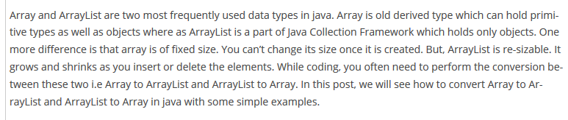

Another difference is that in case of array we have to define the data type where as in case of ArrayList it is not mandatory as it is optional to define data type/or object type due to generic implementation.